KJSCE/IT/TYBTECH/SEM-VI/CC/2021-22



**Experiment No. 3**

**Title: Creating Window Virtual Machine Instance**

**using AWS (IaaS)**

(Autonomous College Affiliated to University of Mumbai)

KJSCE/IT/TYBTECH/SEM-VI/CC/2021-22

**Batch:A4** **Roll No.:1914078** **Experiment No.:3**

**Aim:** Creating Window Virtual Machine Instance using AWS (IaaS) using RDP and executing C++ program on Window Instance.



**Resources needed:** AWS Educate account



**Pre Requisite:** Knowledge of Client Server communication



**Theory:**

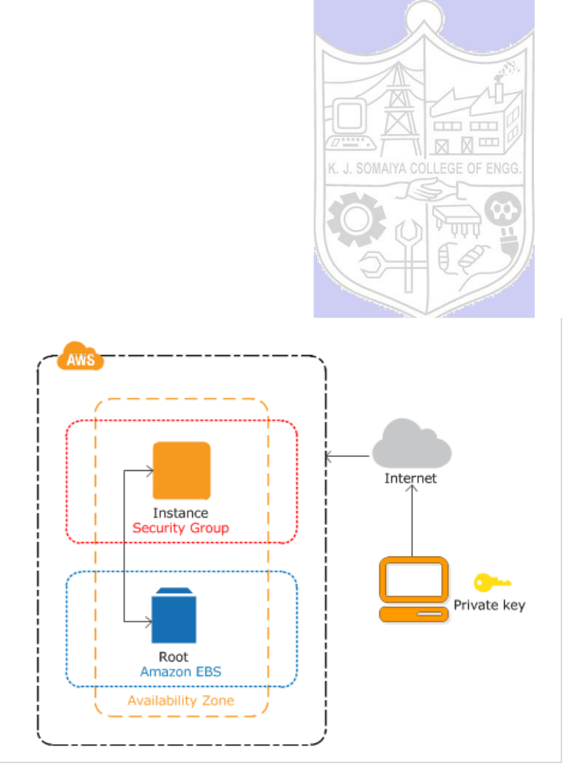

Amazon Elastic Compute Cloud (Amazon EC2) provides scalable computing capacity in the Amazon Web Services (AWS) Cloud. Using Amazon EC2 eliminates the need to invest in hardware up front, so develop and deploy of applications can be faster. Amazon EC2 can be used to launch as many or as few virtual servers as you need, configure security and networking, and manage storage. Amazon EC2 enables you to scale up or down to handle changes in requirements or spikes in popularity, reducing your need to forecast traffic.

It either can be specified the Availability Zone in which the instance is running, or let Amazon EC2 select an Availability Zone. When a instance is launched, it is secured by specifying a key pair and security group.

Fig: EC2 Communication



**Procedure:**

1. Create EC2 window instance. [download private key and RDP desktop client)
2. Download any [DevC++] C++ compiler
3. Execute a sample C++ program



**Results: (Program / Steps with screenshots)**

1. Create EC2 window instance. [download private key and RDP desktop client)

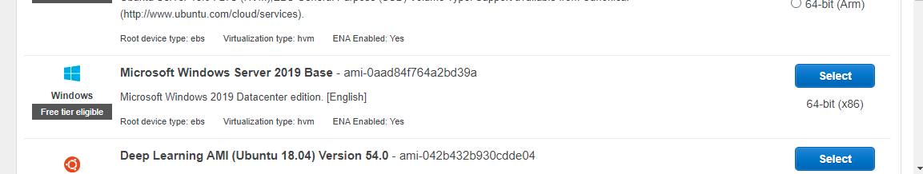

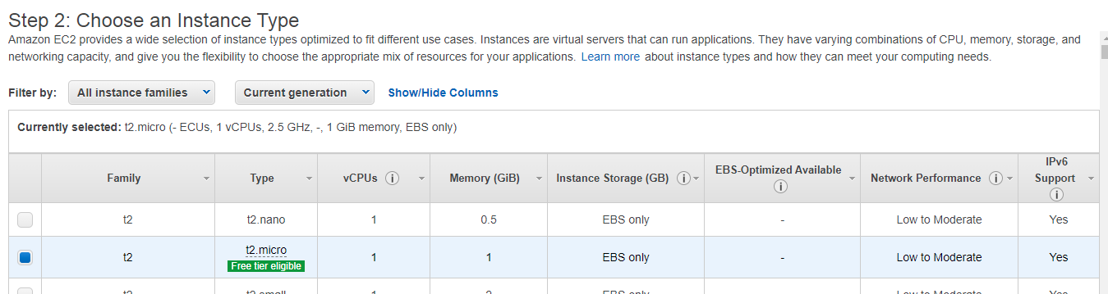

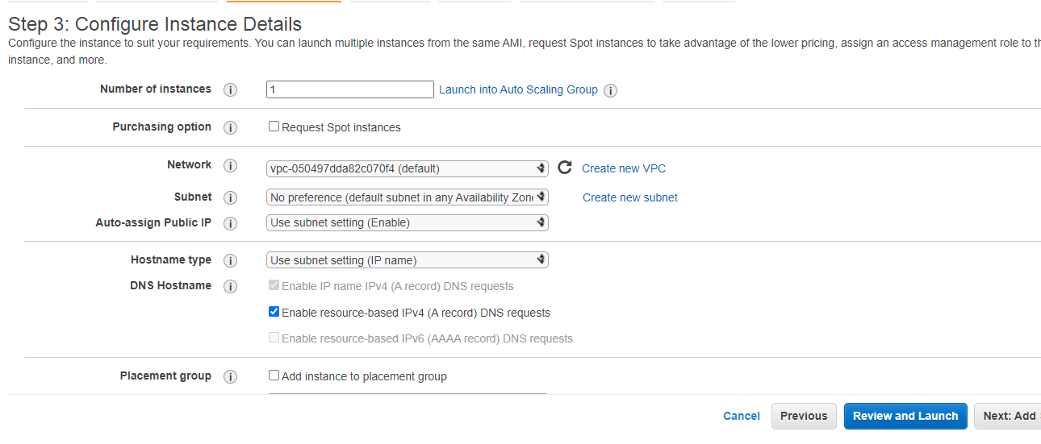

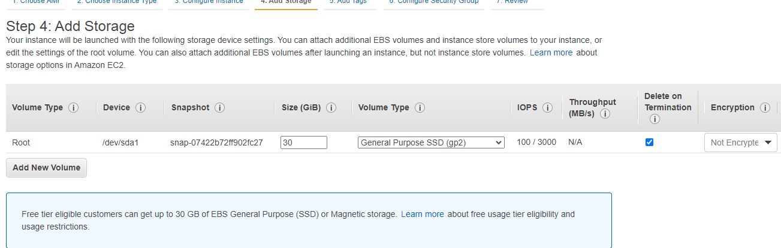

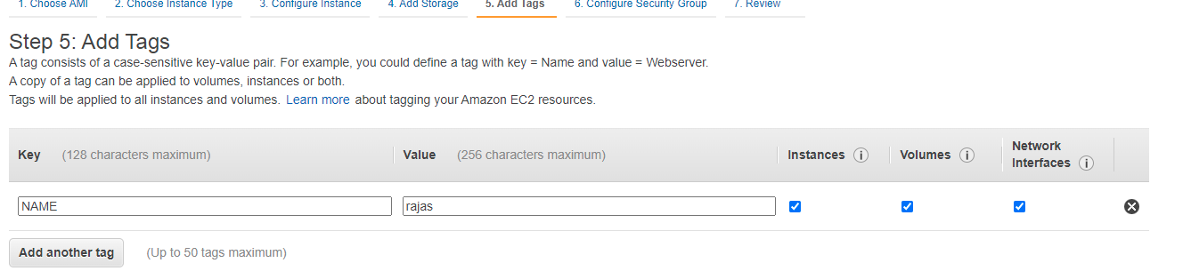

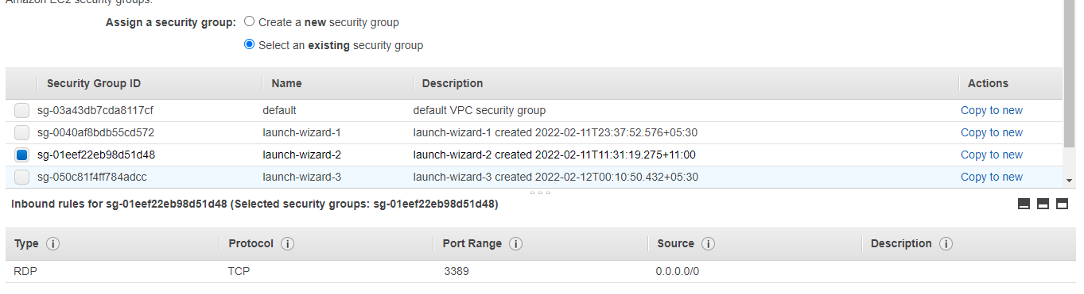

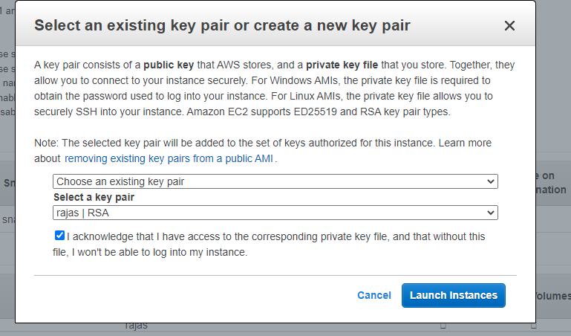

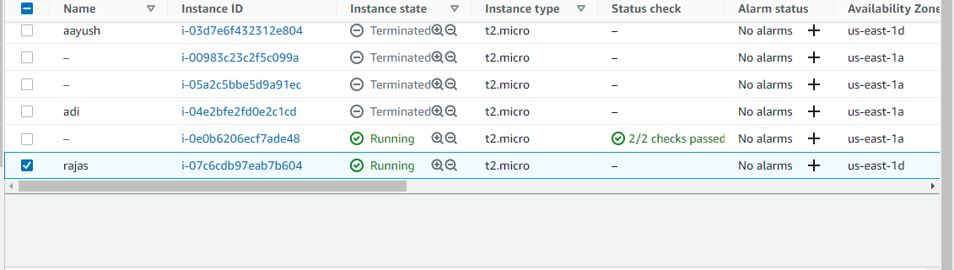

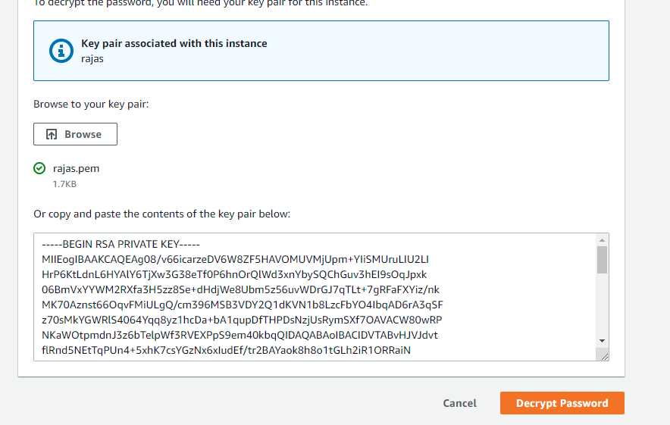

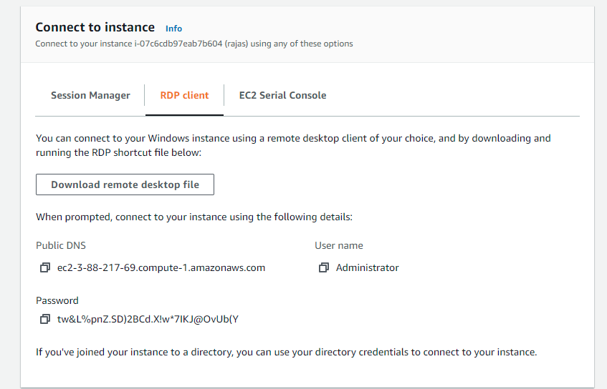

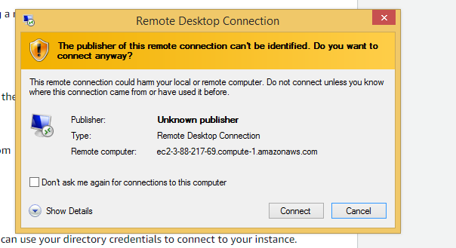

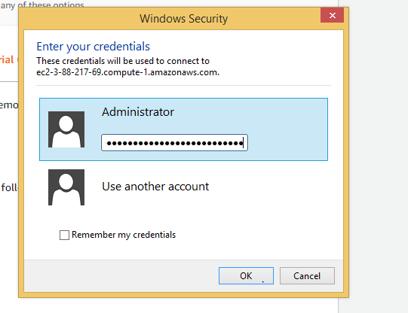

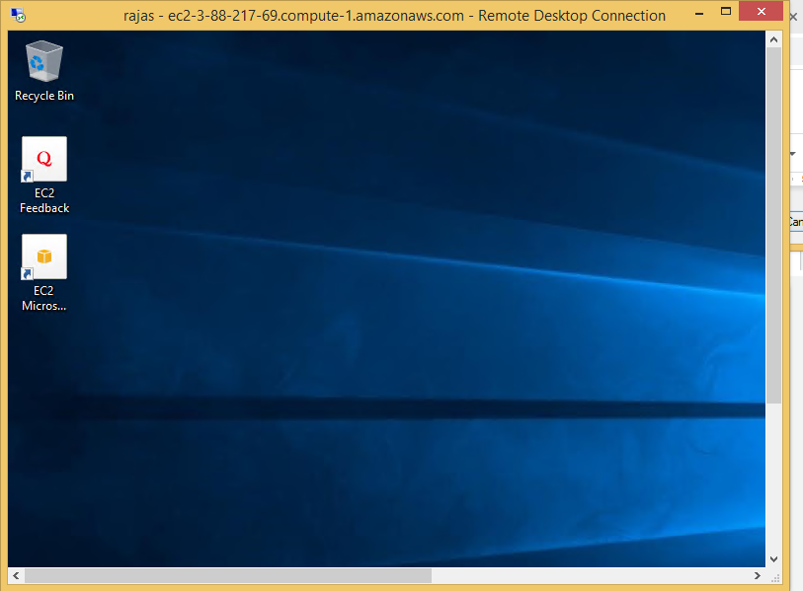

1. [Installing g++ compiler](https://www3.cs.stonybrook.edu/~alee/g++/g++.html)

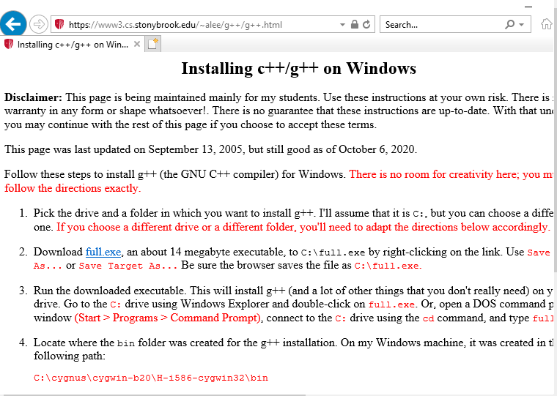

**Running the installer**

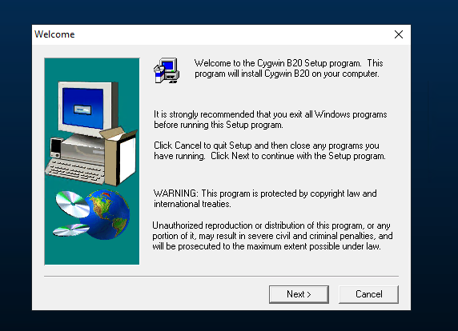



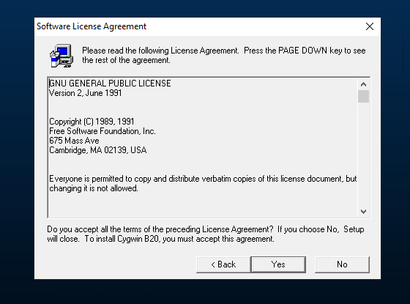

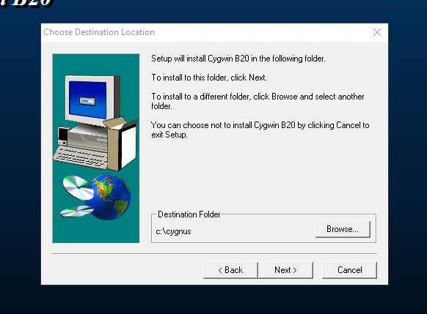

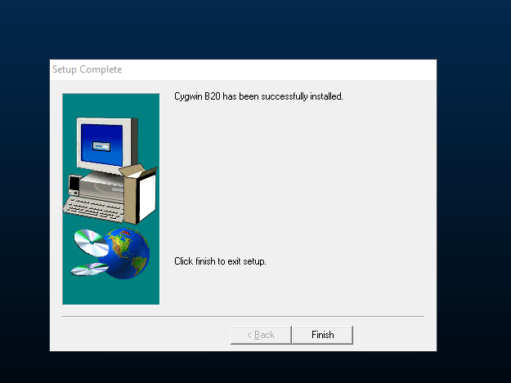

Locating g++ compiler file

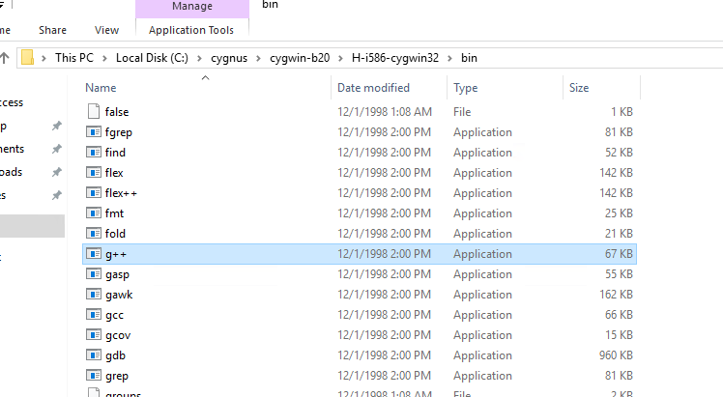

Adding to path

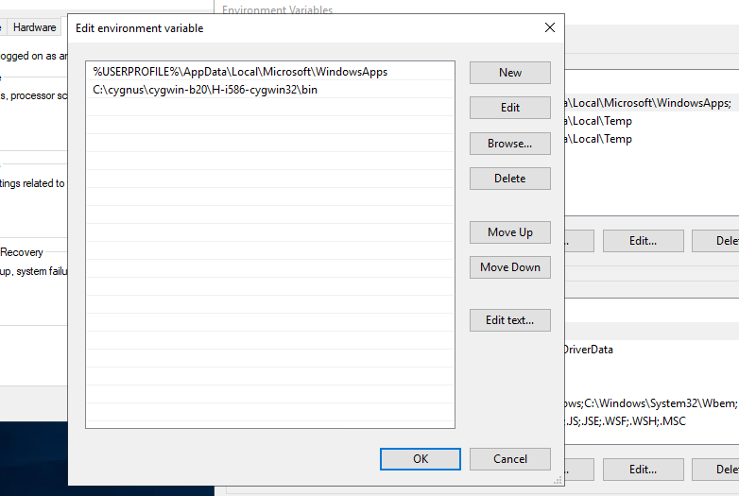

1. Running a C++ code

New code.cpp file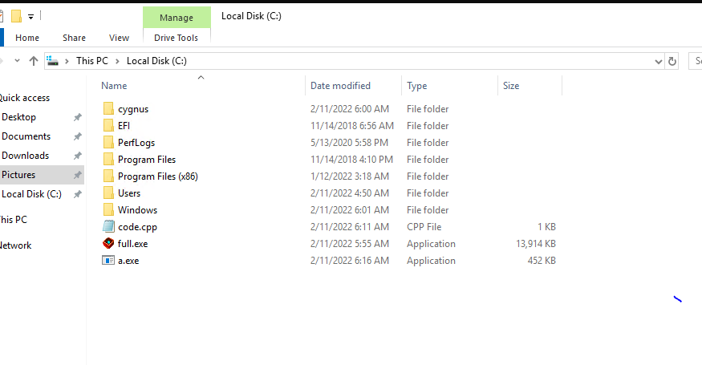

Basic Hello world program

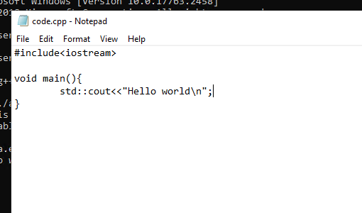

Compiling and running the file

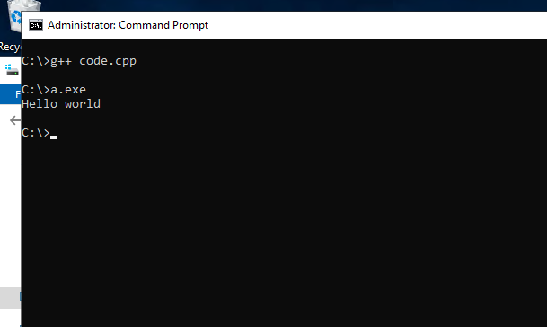

**Questions:**

(Autonomous College Affiliated to University of Mumbai)

KJSCE/IT/TYBTECH/SEM-VI/CC/2021-22

1. Explain two AWS IaaS, PaaS and SaaS services for each?



1. **Iaas**
   1. **EC2**: Amazon Elastic Compute Cloud (Amazon EC2) provides scalable computing capacity in the Amazon Web Services (AWS) Cloud. Using Amazon EC2 eliminates your need to invest in hardware up front, so you can develop and deploy applications faster.
   2. **S3**: Amazon Simple Storage Service (Amazon S3) is an object storage service that offers industry-leading scalability, data availability, security, and performance. Customers of all sizes and industries can use Amazon S3 to store and protect any amount of data for a range of use cases, such as data lakes, websites, mobile applications, backup and restore, archive, enterprise applications, IoT devices, and big data analytics.
2. **PaaS**:
   1. **Elastic Beanstalk:** AWS Elastic Beanstalk is an easy-to-use service for deploying and scaling web applications and services developed with Java, .NET, PHP, Node.js, Python, Ruby, Go, or Docker on familiar servers such as Apache, Nginx, Passenger, and IIS. Elastic Beanstalk is a complete application management solution, and manages all infrastructure and platform tasks on your behalf.
3. **Saas:**
   1. Dropbox.
   2. Salesforce.
   3. Cisco WebEx.
   4. SAP Concur.
   5. GoToMeeting.

**Outcomes:**

Analyze different cloud architectures

**Conclusion: (Conclusion to be based on the objectives and outcomes achieved)**

**Launched a Windows Instance on AWS EC2 and executed a Cpp program**

**Grade: AA / AB / BB / BC / CC / CD /DD**

**Signature of faculty in-charge with date**



**References:**

**Websites:**

1. https://docs.aws.amazon.com/AWSEC2/latest/WindowsGuide/EC2_GetStarted.html

(Autonomous College Affiliated to University of Mumbai)